OGATE
Software Requirement Specification

Project Code: OGate
Document Code: OGate_SRS_v0.1

HCMC, April 2011
RECORD OF CHANGES
*A - Added M - Modified D – Deleted

Effective Date | Changed Items | A*, M, D | Change Description | New Version | PIC
13/4/2011 |  | A | Init | 0.1 | DoanNX

- INTRODUCTION
This document defines the whole OGate system, a web application helps to public the activities, news to community as well as provide a collaboration online environment for members of group. This document tends to be read by all people who are related with system developing. All functional, non-functional requirements, specifications are defined clearly in this document.
  - Purpose
This purpose of this Software Requirement Specification document is to particularly describe customer’s requirements for project.
For consumers: Document describes clearly function requirements of product also other non-function requirements of consumers.
For project team: This document helps project team following customer requirements in order to easy to have exactly analyzing and give suitable solution with requirements. That mean this is an important standard document for design, development, quality assurance, and evolution.
This document can be used to validate and verify content of customer requirements for system after finished and installed.
  - Scope

  - Definitions, Acronyms, and Abbreviations

No. | Acronyms, abbreviations | Definitions

  - References

No. | Resources | Authors | Part of Resources
1 | OGate_High level requirement | ThachLN | All document.

- OVERALL DESCRIPTION

- SPECIFIC REQUIREMENTS
  - Introduction module: this module supplies user the overview information about OOG, such as: group information, the vision and direction of group, group activities...
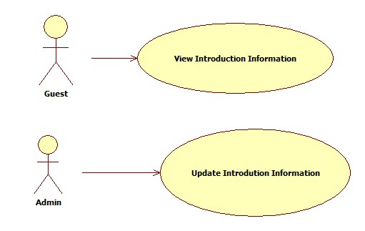
Usecase | View Introduction Information
Short Description | Guest can use this function to view the information of OOG.
Pre-Conditions | Access to Introduction page of this module.
Post-Conditions | -
Main Flow | Access to the Introduction page of this module.
Alternative Flow(s) | -

Usecase | Update Introduction Information
Short Description | Admin of this module can use this function to update the introduction information.
Pre-Conditions | Access to this module with Admin role.
Post-Conditions | The introduction information is updated.
Main Flow | 1/ Click on Update link on the Introduction page.  2/ System displays the content of introduction information (should be in a text area) to update.  3/ Click on Update button.  4/ System saves the updated content into database and displays message “Updated successfully!”.  5/ System redirects to Introduction page.
Alternative Flow(s) | 4.1/ If the updated content is not blank or not valid, system shows the error dialog with 2 buttons OK and Cancel and one message “The updated content is not valid. Please try again!”.  4.1.1/ If user click OK button, system will focus on the introduction information part.  4.1.2/ If user click Cancel button, redisplay Introduction page.

  - Product module: this module allows to introduce about OOG's products, number of downloads, feedback as well as comment of user...

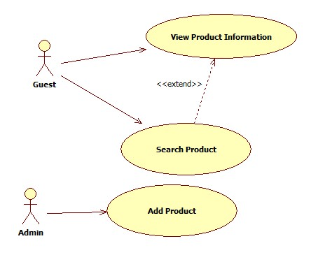

Usecase | View Product Information
Short Description | Guest can use this function to view the detailed information of OOG's products, such as: product name, product description, release information as well as list of feedback and creating his/her feedback.
Pre-Conditions | Access to ProductInfo page of this module.
Post-Conditions | His/her feedback will be saved into database (if any).
Main Flow | 1/ Access to the ProductInfo page in OGate site.  2/ System displays the information of the current product, including: product name, product description, release information and list of feedback.  3/ In case user want to leave his/her feedback:  3.1/ He/she must input these following information into the correspondence controls:  a. Name  b. Email  c. Confirm code  d. Rating  e. His/her comment  3.2/ If the client validation is OK, he/she click on the Send button to submit his/her feedback.  3.3/ If the server validation is OK, this feedback will be saved into database.  3.4/ System shows one dialog with message “Thank for your feedback!”.  3.4/ The latest feedback will be updated in List of feedback immediately.
Alternative Flow(s) | 3.2.1/ In these following cases, the client validation is fail:  a. Name is blank or not “_a-zA-Z0-9”.  b. Email is blank or not a valid email address.  c. Confirm code is not correctly (CAPTCHA library can be used for the confirm code).  d. Rating has not choosen yet.  e. Comment is blank.  And the error message will be displayed inline.  3.2.2/ System will focus on the first control which is wrong value.

Usecase | Search Product
Short Description | Guest can use this function to search the OOG's products, following some criteria, such as: project name/project code, category...
Pre-Conditions | Access to SearchProduct page of this module.
Post-Conditions | The available products will be displayed.
Main Flow | 1/ Access to SearchProduct page in OGate site.  2/ User inputs the project name or project code.  3/ User click on Search button.  4/ If the validation check is OK, system will display the quantity and the information of available products.  4.1/ The information of one product includes:  a. Project code (link to View Product Info usecase)  b. Project name (link to View Product Info usecase)  c. Project description  d. Status  e. Mark (follow level 5)  f. Number of Downloads
Alternative Flow(s) | 2.1/ User can search/filter by Alphabet  2.1.1/ Click on the A → E link to filter the products which its name begins with A → E character.  2.1.2/ Click on the F → J link to filter the products which its name begins with F → J character.  2.1.3/ Click on the H → L link to filter the products which its name begins with H → L character.  2.1.4/ Click on the M → P link to filter the products which its name begins with M → P character.  2.1.5/ Click on the Q → Z link to filter the products which its name begins with Q → Z character.  2.2/ User can search/filter by Category  2.2.1/ User chooses the main category  2.2.2/ System displays the available sub category of this main category  2.2.3/ User chooses the sub category

Usecase | Add Product
Short Description | Admin can use this function to add the new one into OOG's products.
Pre-Conditions | Access to this module with Admin role.
Post-Conditions | The new product is saved into database.
Main Flow | 1/ Access to AddProduct page in this module.  2/ Admin inputs these following information for the new product:  a. Project code.  b. Project name.  c. Project description.  d. Status.  e. Category, including Main Category and Sub Category.  3/ Admin click on Add button.  4/ If the validation check is OK, system will save the new product into database and display the message “The new product has been added successfully!”.
Alternative Flow(s) | 4.1/ In these following cases, the validation check is fail:  a. Project code is blank or not “_a-zA-Z0-9”.  b. Project name is blank or not “_a-zA-Z0-9”. c. Project description is blank or not valid.  d. Status has not choosen yet.  e. Category has not choosen yet.  And the error message will be displayed inline.  4.2/ System will focus on the first control which is wrong value.

  - Service module: this module supplies user the information about OOG's services, including sharing experience/skill, training about software development, providing training for intern students and participant organizations, cooperating in building software product and human resource service.

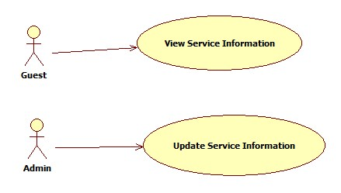
Usecase | View Service Information
Short Description | Guest can use this function to view the information of OOG's services.
Pre-Conditions | Access to Service page of this module.
Post-Conditions | -
Main Flow | Access to the Service page of this module.
Alternative Flow(s) | -

Usecase | Update Service Information
Short Description | Admin of this module can use this function to update the introduction information.
Pre-Conditions | Access to this module with Admin role.
Post-Conditions | The service information is updated.
Main Flow | 1/ Click on Update link on the ServiceInformation page.  2/ System displays the content of service information to update.  3/ Click on Update button.  4/ If validation check is OK, system saves the updated content into database  5/ System redirects to ServiceInformation page.
Alternative Flow(s) | 4.1/ If the updated content is not blank or not valid, system shows the error dialog with 2 buttons OK and Cancel and one message “The updated content is not valid. Please try again!”.  4.1.1/ If user click OK button, system will focus on the introduction information part.  4.1.2/ If user click Cancel button, redisplay ServiceInformation page.

  - Forum module: it provides a forum for exchange of experiences and skill in software development.
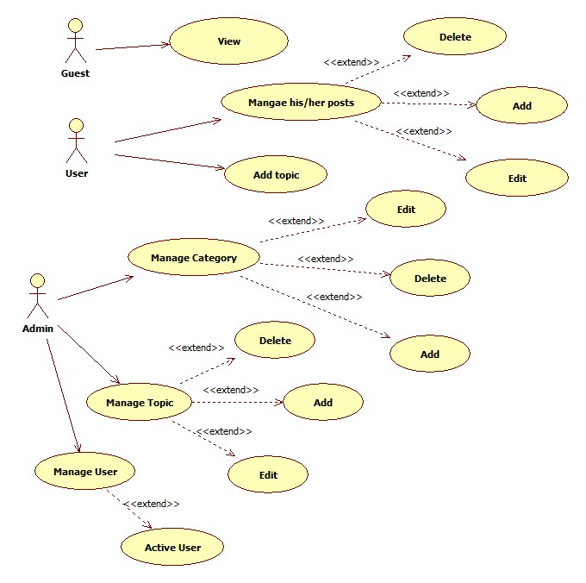
  - Member module: it provides the information of OOG's members.
  - Project module: it provides necessary tools to manage OOG's projects, such as: make idea tool, requirement, basic design, detailed design, SVN management, quality management.
  - Job module: it provides the profile/CV of OOG's members.
  - Activity module: introduce about the OOG's next activities.

